**FSM-FINITE STATE MASHINE**

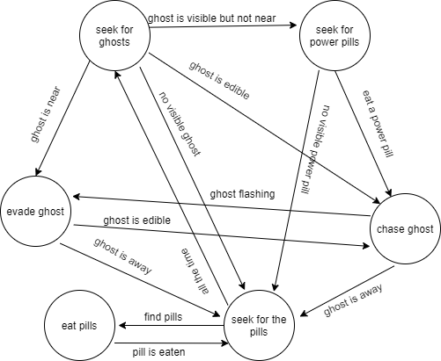

**BEHAVIOR TREE**

